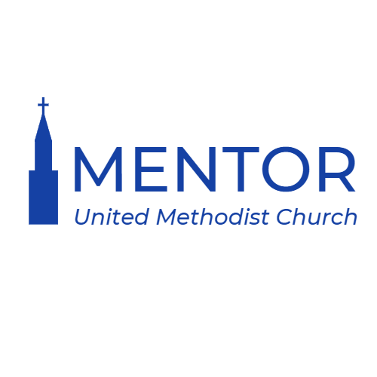

Lay Leader Report for Charge Conference 2023
Written by Andrea Gingrich

Mentor United Methodist Church fulfills its mission to “Lead all onto a path of Christ-centered discipleship” by focusing on our vision: to help all people grow Upward in Worship, Deeper in Discipleship, Together in Christian Community, and Outward in Service. Throughout 2023, MUMC continued to make this mission statement a top priority.
In January of 2023 MUMC began to re-evaluate its administrative council and began to gather in person regularly to spark new life into this body of leadership. A new Administrative Council chairperson was appointed and the team created a structured list of its administrative members and voting members. The team also discussed basic procedural practices that the team agreed upon for its meeting. Much discussion was had about best practices for decision making within the church in regards to the Administrative Council and although restructuring was discussed, the team decided to stay the course with the current model. The team continues to find new and creative ways to share their reports from their respective committees so as to best streamline the process for everyone involved.
2023 was a year of transition for MUMC. In July of 2023, Pastor Steve Stultz Costello and Pastor Ivy Smith were assigned to lead our congregation. The transition to our new leadership has been smooth, in part, because our mission statement and vision are embraced by our congregation. Our leadership continues to work together in addressing our goals so that MUMC will continue to honor Christ, as well as help new persons come to know Christ.
After much consideration and discernment between the parish and our new leadership, the staff decided to adjust our summer worship schedule to allow our pastors to worship together. This schedule offered one modern worship service at 9:00 am and one traditional worship service at 11:00 am. The change made our worship center and sanctuary feel full and alive and the congregation was responsive to the change.

